**Supplemental Materials for ‘Strengthening causality in the mediator-outcome relationship: Experimental mediation and the use of instrumental variable regression’**

Table of Contents

S1 Additional Results under Normality Assumptions 2

S1.1 Estimation Bias of the Indirect Effect 2

S1.2 Coverage Rate of the Indirect Effect 4

S2 Results with Non-normal data 6

S2.1 Estimation Bias of the Indirect Effect 6

S2.2 Coverage Rate of the Indirect Effect 8

# S1 Additional Results under Normality Assumptions

In the supplemental figures, a, b, d, and v represent standardized regression coefficients in Figure 4.

## S1.1 Estimation Bias of the Indirect Effect

**Figure S1.**

*Estimation Bias of the Pure Natural Indirect Effect with Normal Data*

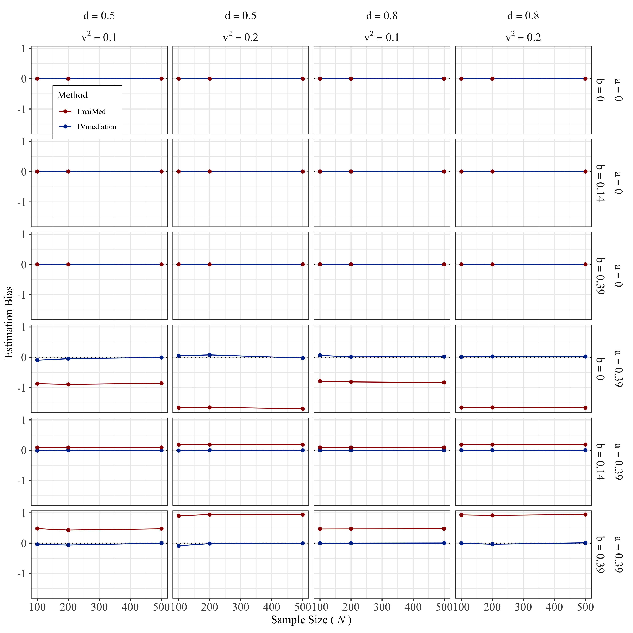

*Note.* The horizontal black dotted line marks 0 Estimation Bias.

**Figure S2.**

*Estimation Bias of the Total Natural Indirect Effect with Normal Data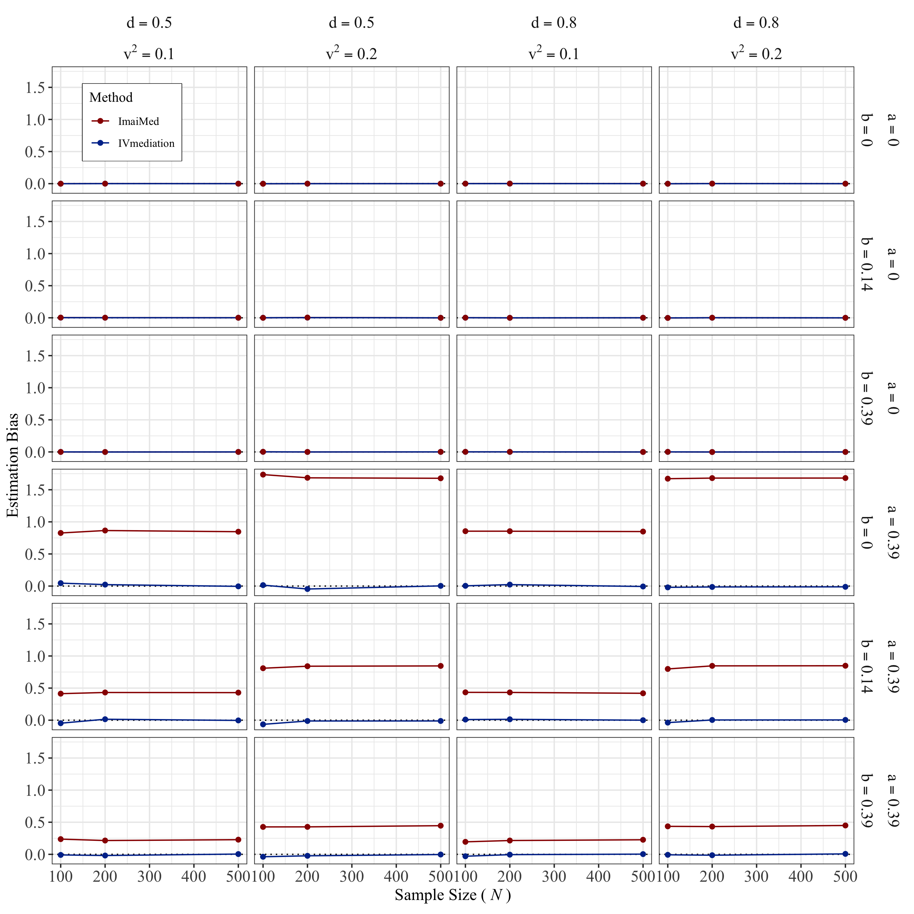*

*Note.* The horizontal black dotted line marks 0 Estimation Bias.

## S1.2 Coverage Rate of the Indirect Effect

**Figure S3.**

*Coverage Rate of the Pure Natural Indirect Effect with Normal Data*

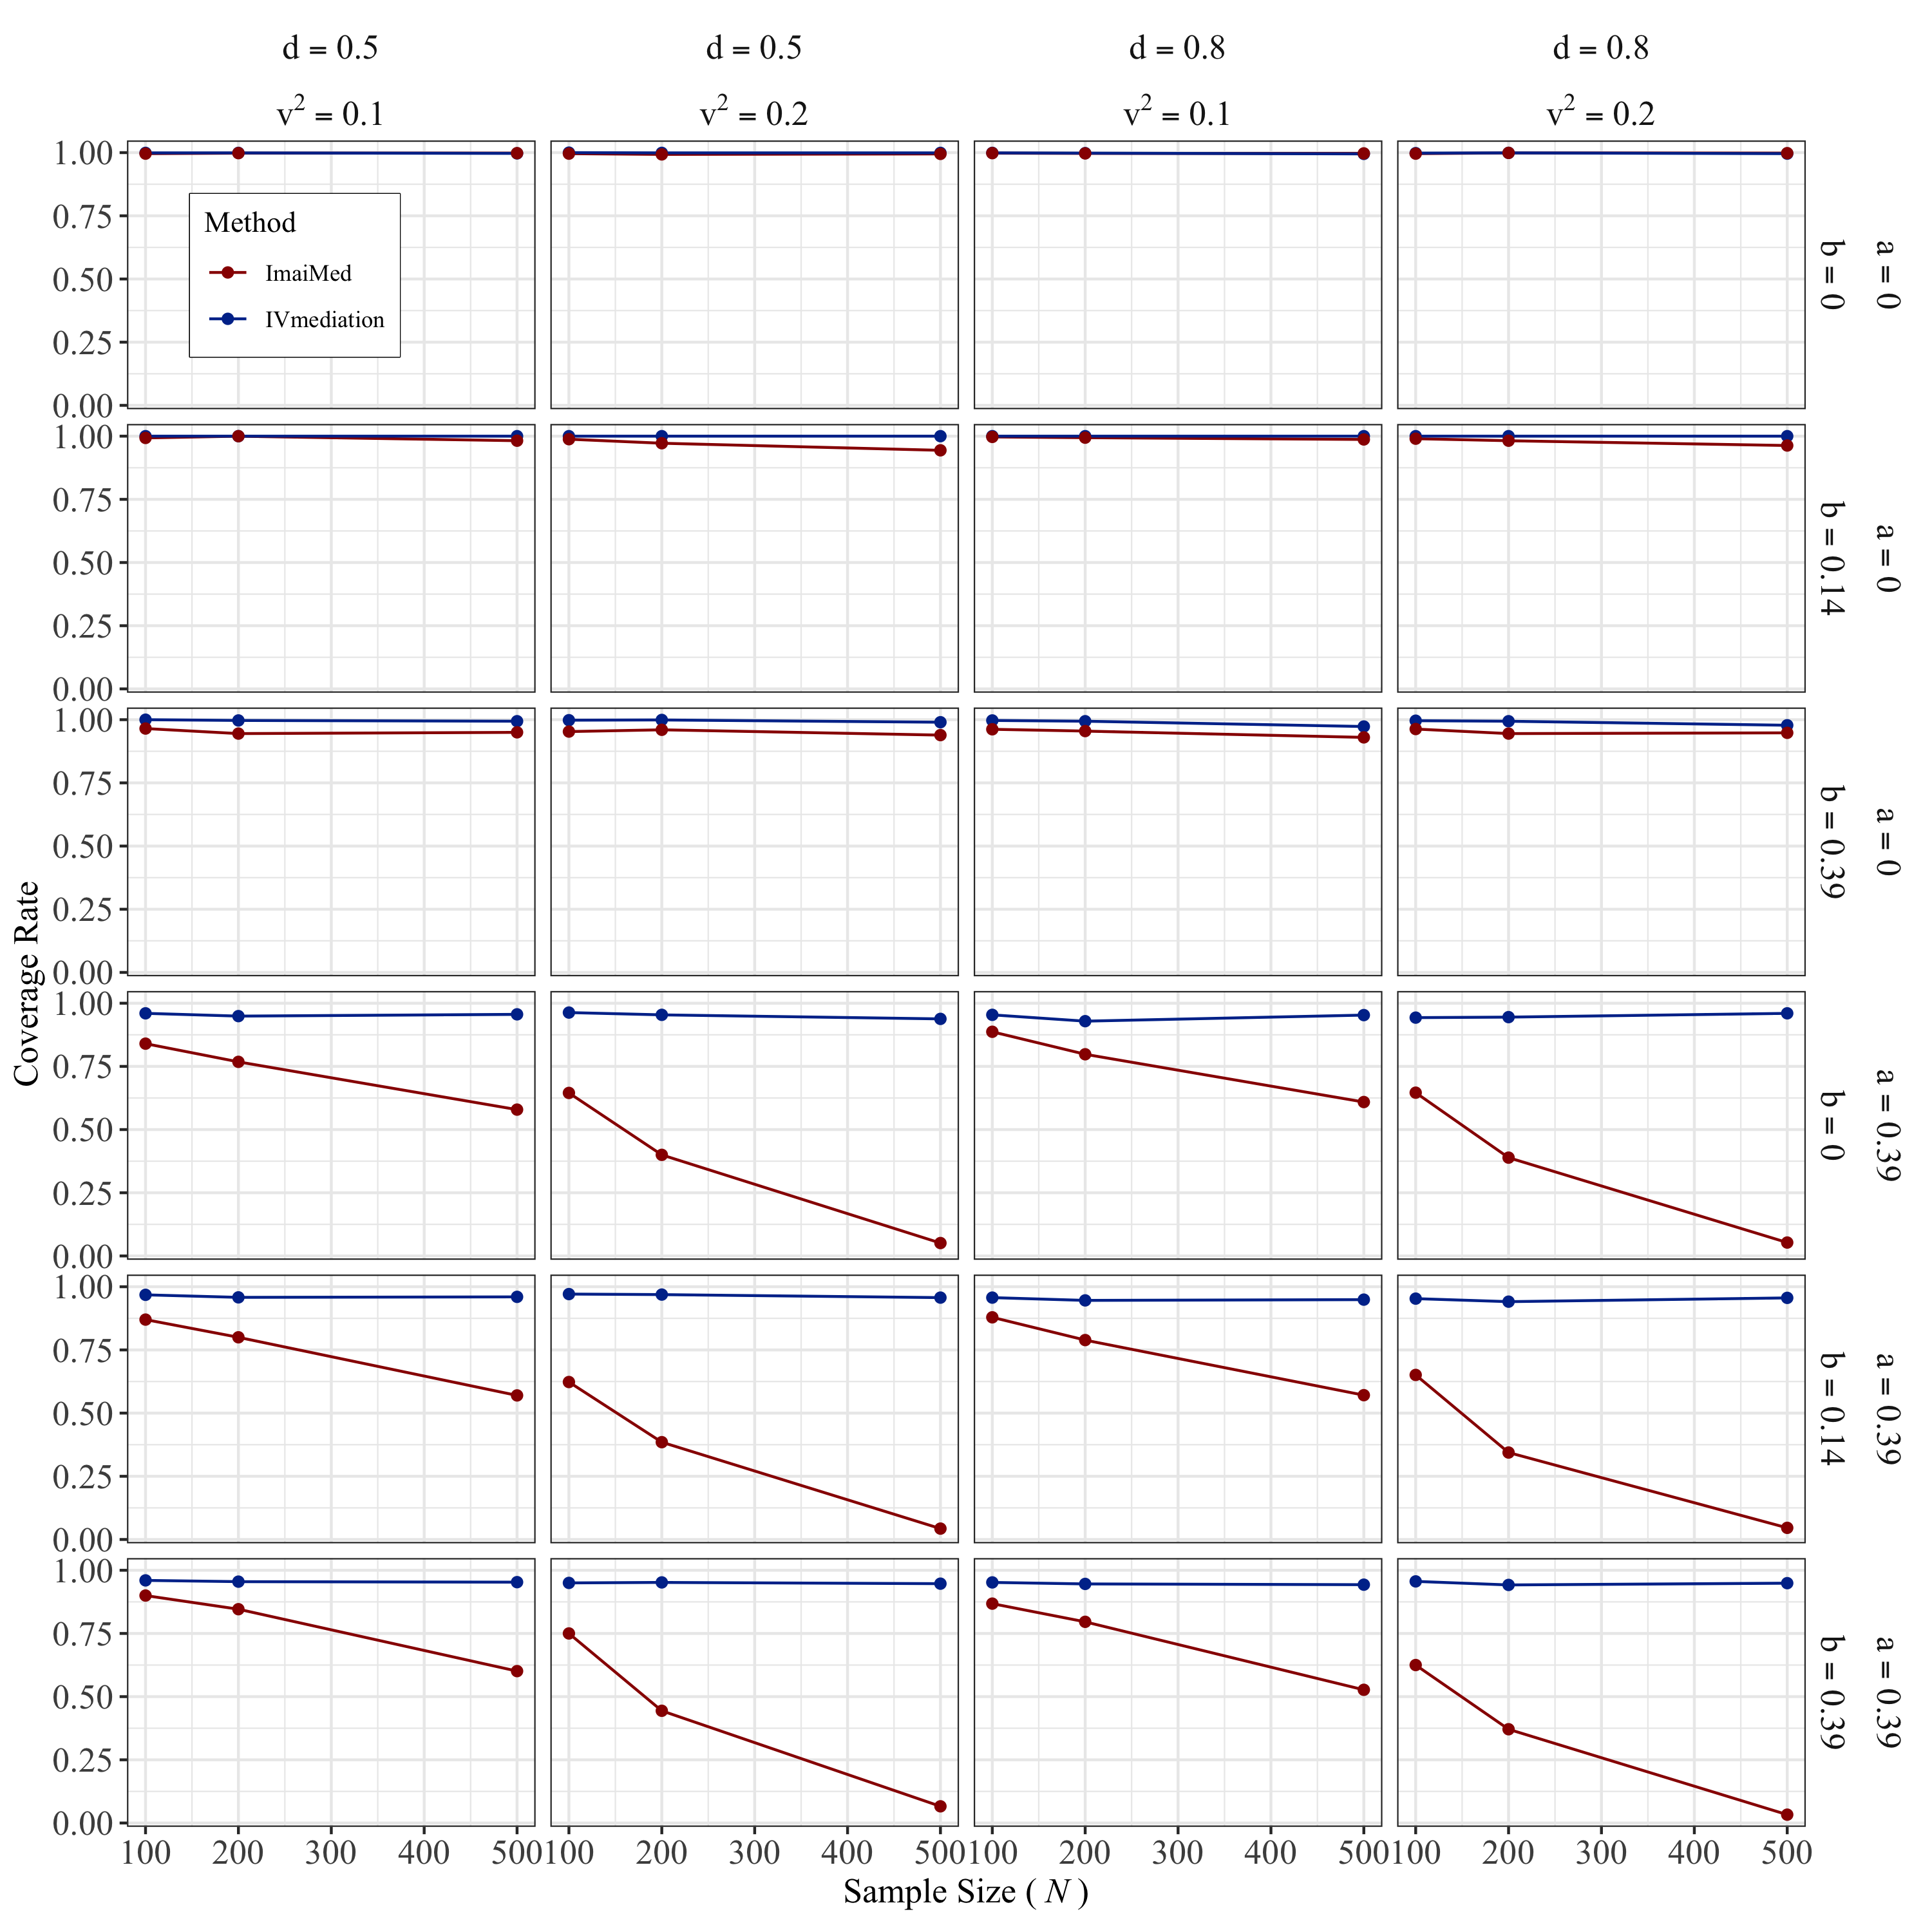

**Figure S4.**

*Coverage Rate of the Total Natural Indirect Effect with Normal Data*

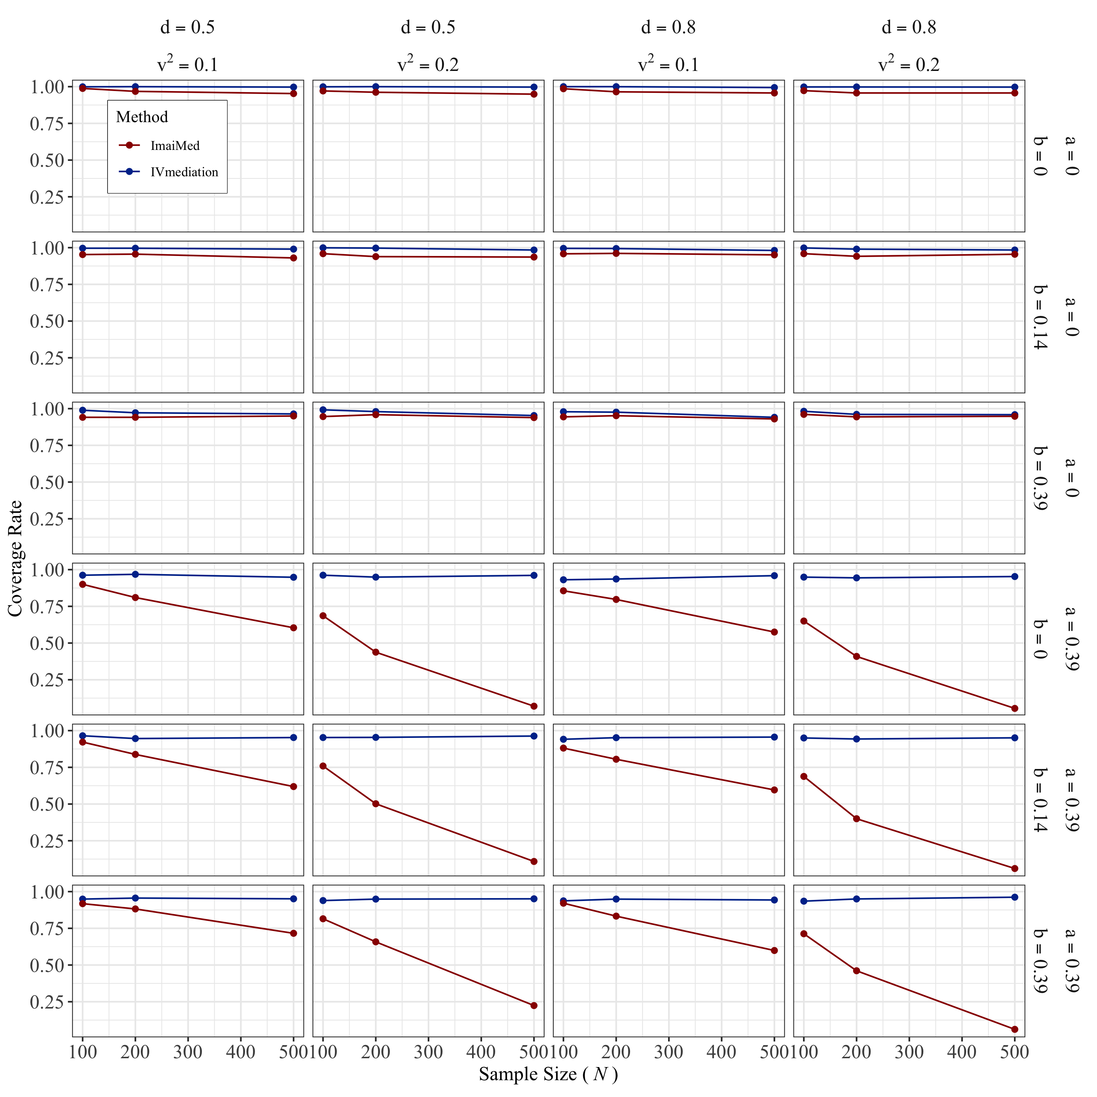

# S2 Results with Non-normal data

## S2.1 Estimation Bias of the Indirect Effect

**Figure S5.**

*Estimation Bias of the Pure Natural Indirect Effect with Non-normal Data*

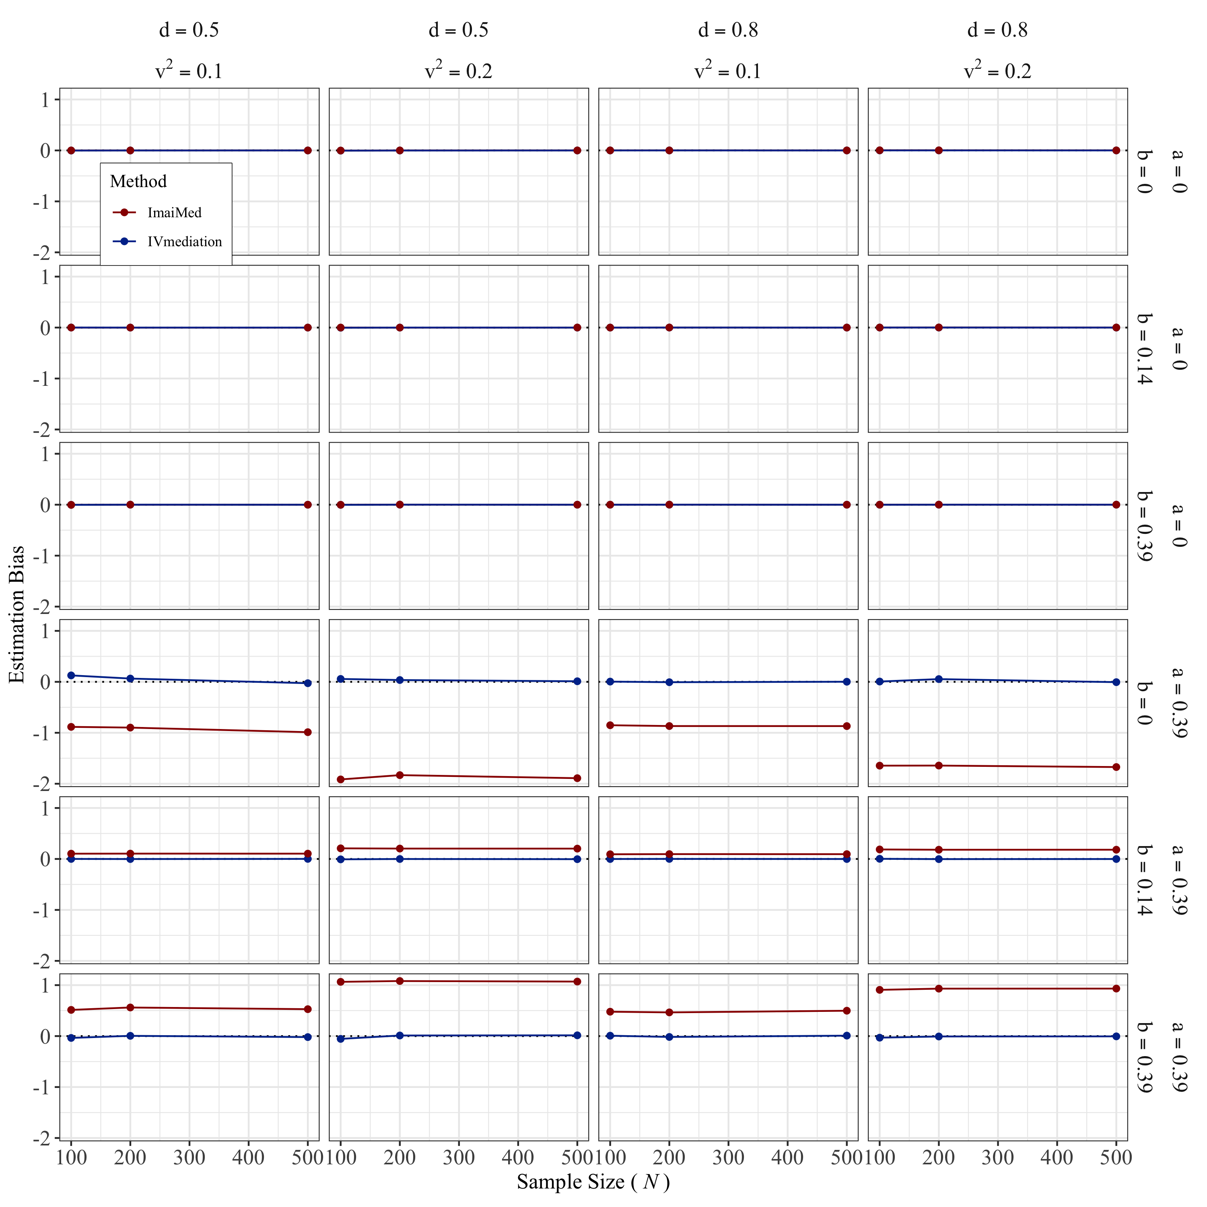

*Note.* The horizontal black dotted line marks 0 Estimation Bias.

**Figure S6.**

*Estimation Bias of the Total Natural Indirect Effect with Non-normal Data*

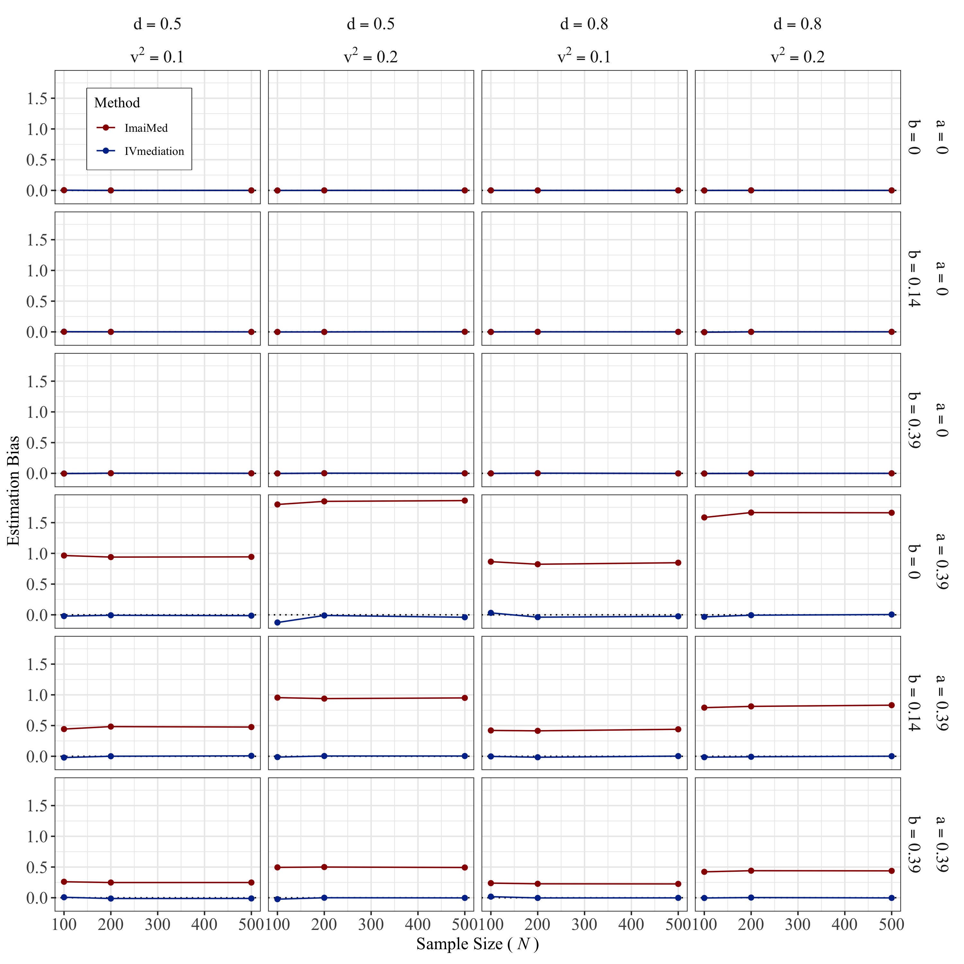

*Note.* The horizontal black dotted line marks 0 Estimation Bias.

## S2.2 Coverage Rate of the Indirect Effect

**Figure S7.**

*Coverage Rate of the Pure Natural Indirect Effect with Non-normal Data*

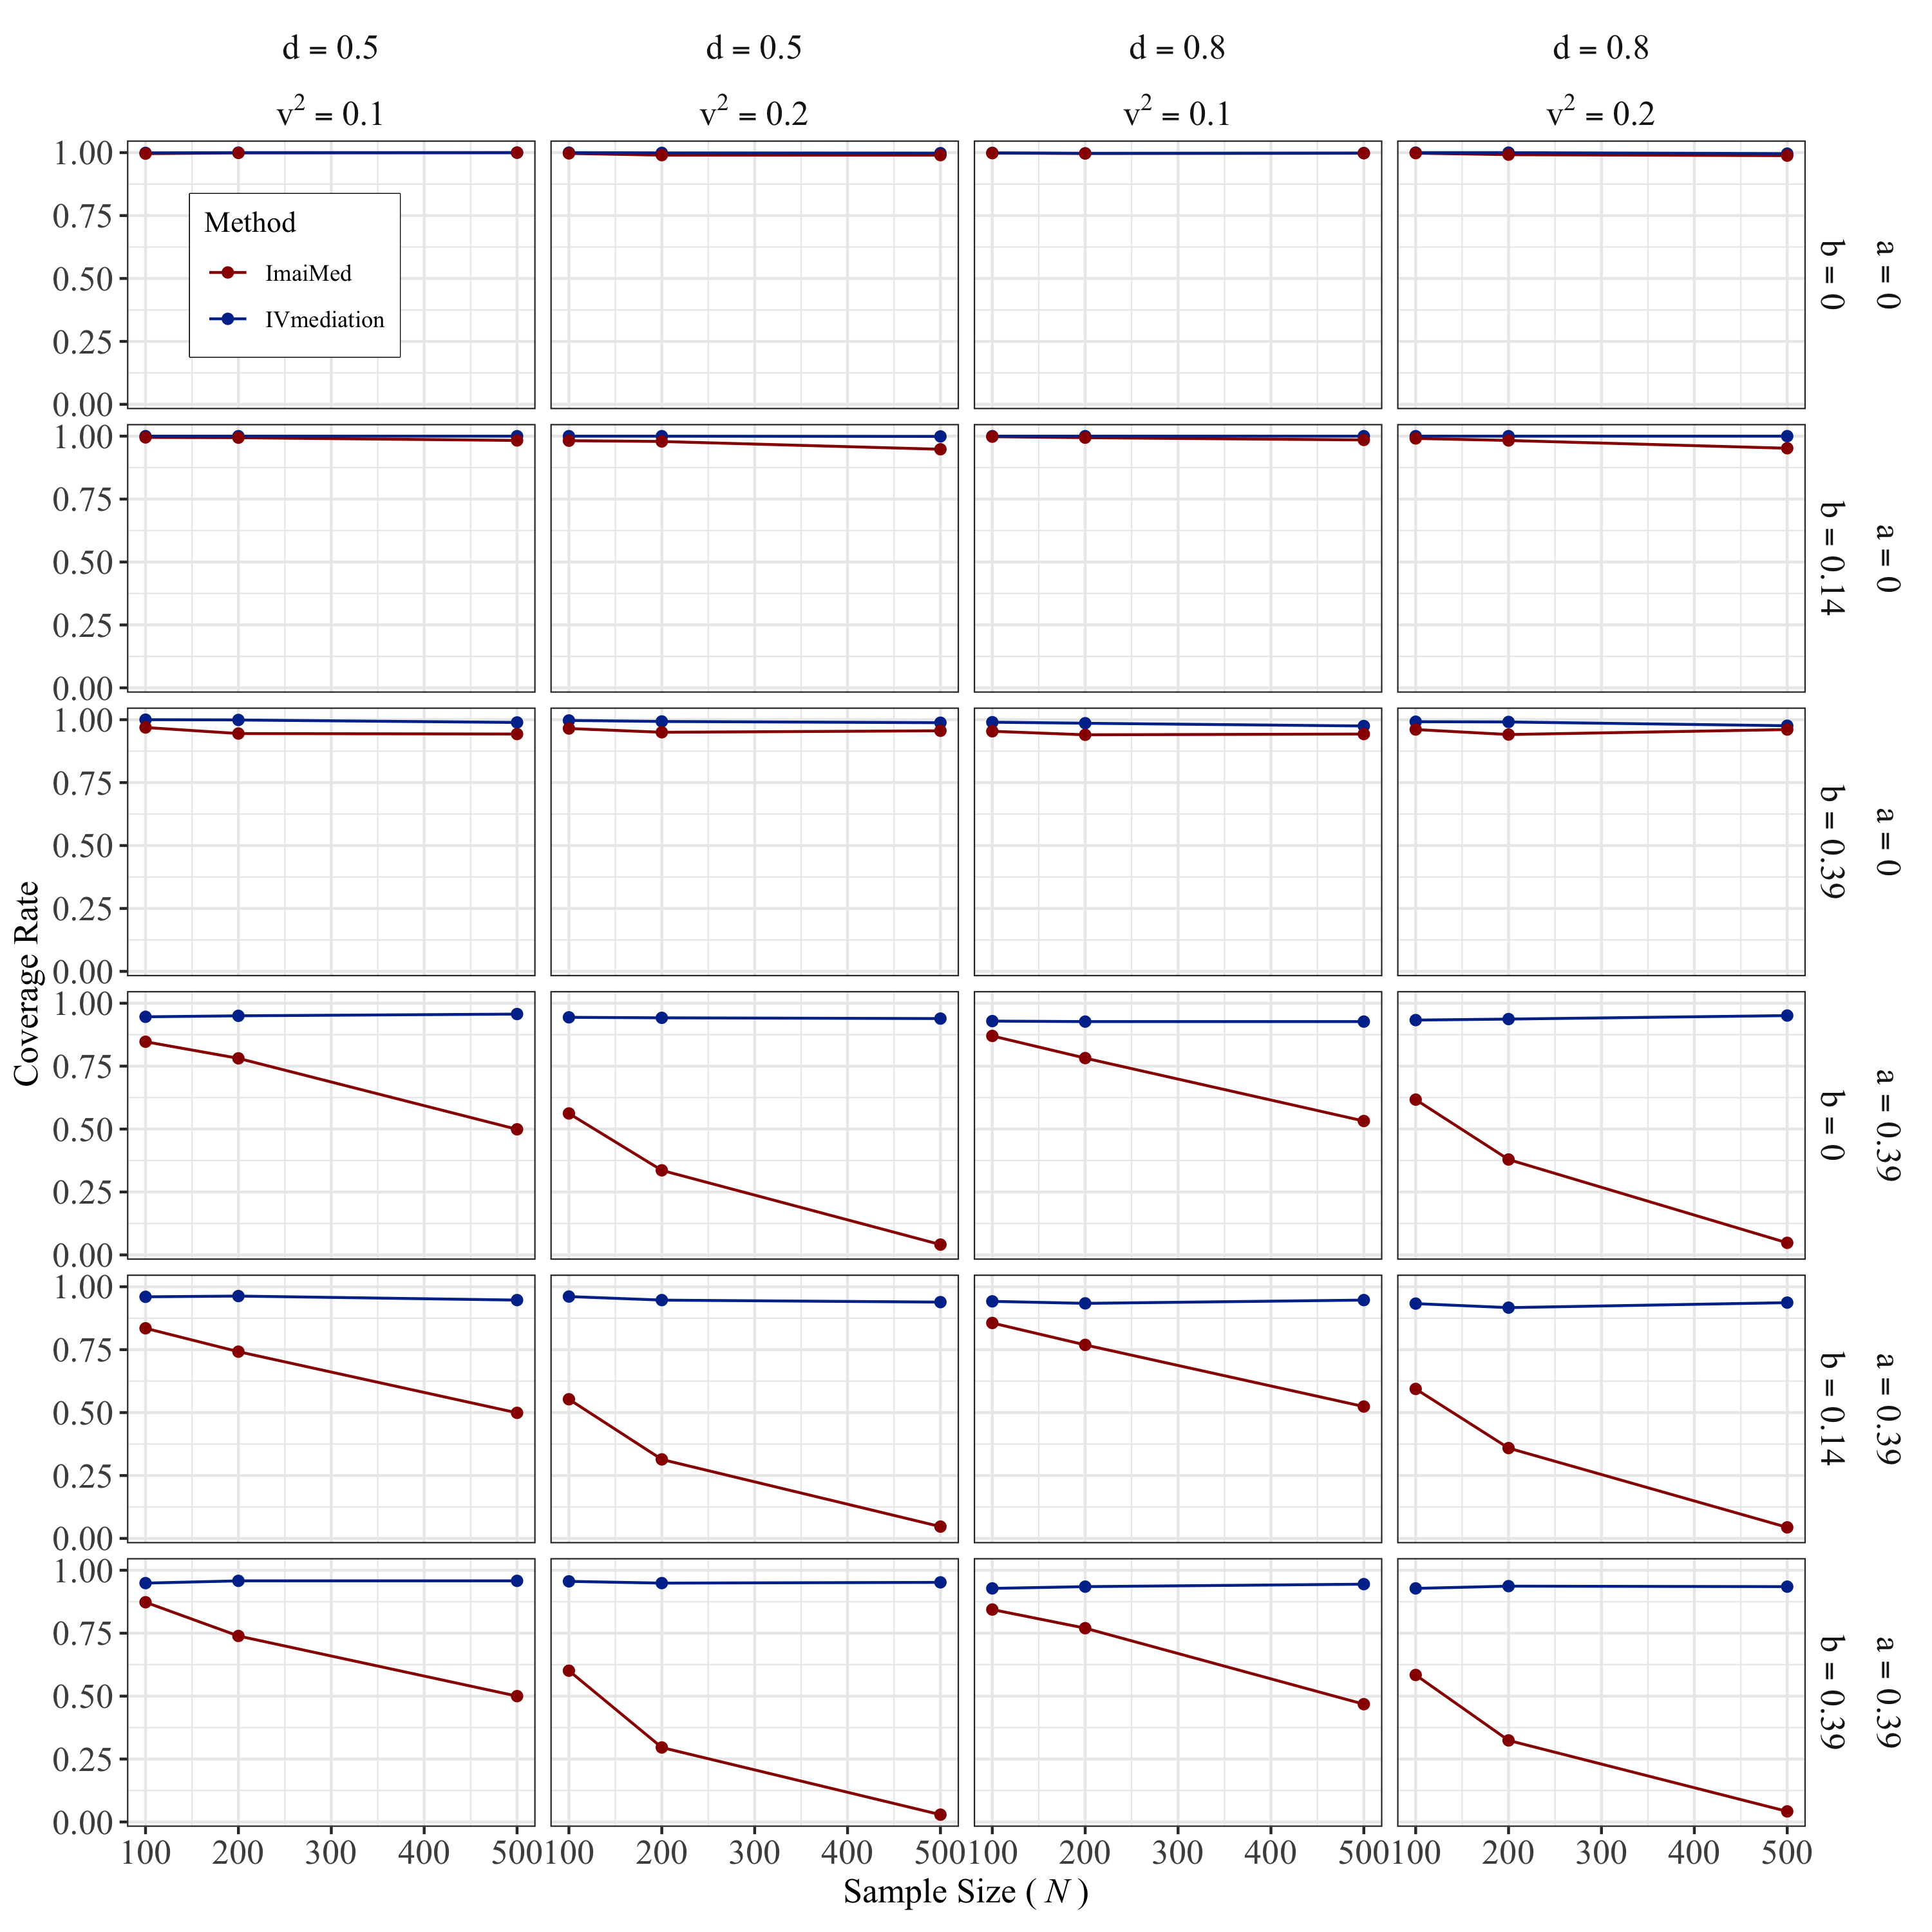

**Figure S8.**

*Coverage Rate of the Total Natural Indirect Effect with Non-normal Data*

